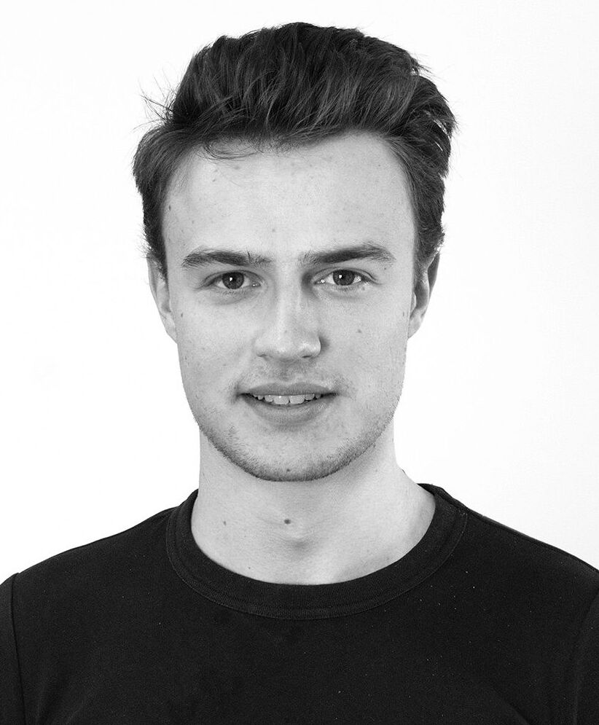
Gilles Van De Vyver
Trondheim, Norway
+32 474 07 94 43
gillesvandevyver1@gmail.com
gillesvandevyver.com | github.com/gillesvntnu
LinkedIn | Google Scholar

PROFILE_____________________________________________________________________
ML engineer with a PhD in applied deep learning and four years of professional software engineering. I take models from paper to production under hard latency and memory constraints: choosing them on measured evidence rather than reputation, exporting them to ONNX, quantising them, and running them in real time, on a microcontroller inside a wearable device and in a browser tab with no server behind it. I care most about the gap between a model that scores well on a benchmark and one that works in the field.
WORK EXPERIENCE_____________________________________________________________
- 2025 - present: Software architect and AI engineer at Sonofit, Trondheim (full time)
  - Own the technical architecture of a wearable ultrasound device end to end: on-device inference, signal and image processing pipeline, and system design.
  - Took the product from nothing to a working, useful prototype in three months, with neural networks running in real time on the device.
  - 100 FPS inference at 0.8 s end to end latency on an STM32 microcontroller, with an AI model compressed to a few kilobytes. Architecture selection, ONNX export, quantisation and operator level optimisation under hard compute, memory and power limits.
  - Made the models work on genuinely messy data: echo captured on a moving body during sport. Built the evaluation harness that decides which model ships.
- 2025 - present: Researcher at NTNU, Trondheim (20%)
  - AI foundation models for echocardiography: evaluating pre-trained encoders and the embeddings they produce for downstream tasks.
- 2025: AI consultant at Inphase Solutions (part time, alongside the PhD)
  - Built a vision system that determines the sex of sedated salmon, used in the industrial pipeline of the vaccination machines of Maskon.
- 2022 - 2025: PhD, applied deep learning for cardiac ultrasound. NTNU and St. Olav's University Hospital, Trondheim
  - Robust and reliable machine learning for cardiac ultrasound. Evaluated model behaviour under distribution shift and real clinical acquisition conditions: the same question as whether a new model actually helps on your own data, not on a public benchmark.
  - Released the resulting tools publicly. They are currently in use by clinical research teams in Norway, the Netherlands, Belgium and Spain.
  - Three first author papers and two as co-author. Supervised two master's students through to publication.
  - Applied focus throughout, working closely with cardiologists as the end users.
- Earlier: Python teaching assistant at KU Leuven (2022), researcher at KU Leuven (summer 2022), data scientist at ArcelorMittal (summer 2021), data analyst at Sweco (summer 2021).
RETRIEVAL AND LLM PROJECTS__________________________________________________
- Ask a Bike Question, retrieval augmented generation running entirely in the browser
  - End to end retrieval pipeline in production on my webpage with no backend: 255 articles chunked, embedded and int8 quantised at build time into a 1.3 MB index, then searched client side by hybrid BM25 and dense retrieval fused by reciprocal rank, with optional LLM answer synthesis.
  - Chose the encoder by measurement, not reputation: six candidates scored on a hand labelled query set over the same corpus, where e5-small-v2 reached MRR 0.962 against 0.827 for the common all-MiniLM default. Retrieval holds docP@1 0.93, with similarity floors calibrated against unanswerable questions so the system says when it does not know.
  - https://gillesvandevyver.com/#/projects/ask-a-bike-question
- DeepEcho agentic, agentic multimodal LLM with custom AI tools
  - Makes complex echo analysis accessible through natural language while keeping the reliability of tested tools: the LLM orchestrates, the deterministic tools compute.
  - https://gillesvandevyver.com/#/projects/agentic-ai
EDUCATION___________________________________________________________________
- 2022 - 2025: PhD in machine learning and medical imaging at NTNU, Trondheim.
- 2020 - 2022: Master artificial intelligence at KU Leuven. Graduated magna cum laude.
  - Focus on deep learning, statistics, and big data.
  - Erasmus at KTH Stockholm. A grade on all courses.
- 2018 - 2020: Bachelor engineering at KU Leuven. Graduated magna cum laude.
  - Major computer science, minor electrical engineering.
SKILLS______________________________________________________________________
Retrieval and LLMs: Embeddings and vector retrieval, RAG, hybrid lexical and dense search with rank fusion, chunking and reranking, retrieval evaluation and calibration, transformers and foundation models, LLM agents and tool use
ML engineering: PyTorch, Tensorflow and Hugging Face, ONNX export, quantisation and model compression, real time and embedded inference, evaluation under distribution shift
Programming languages: Python, C/C++, Javascript/Typescript, C#, Matlab, Java (academic), SQL
Other: Docker, Kubernetes, AWS, MongoDB, Git
Languages: English: C2, Norwegian: B2, Dutch: native, French: B1/B2

